**Practical 03 Configure Hyper Text Transfer Protocol(HTTP) and Domain Name System(DNS) in Packet Tracer.**

Step-1: Take one server and one end device such as PC or laptop

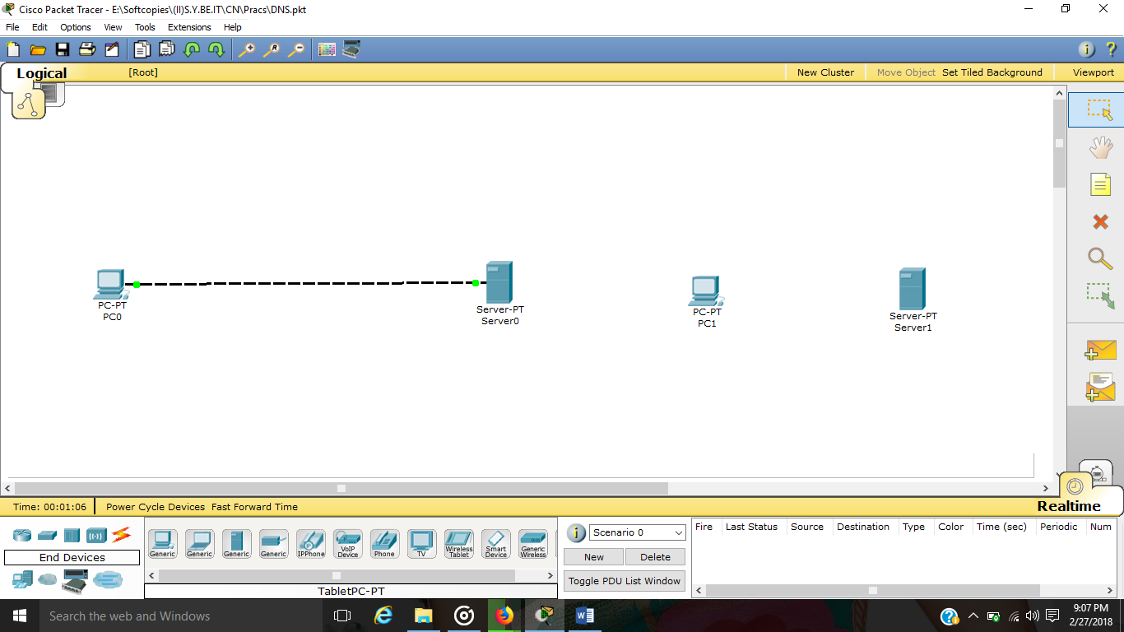

Step-2: Choose Automatic connection and connect both devices.

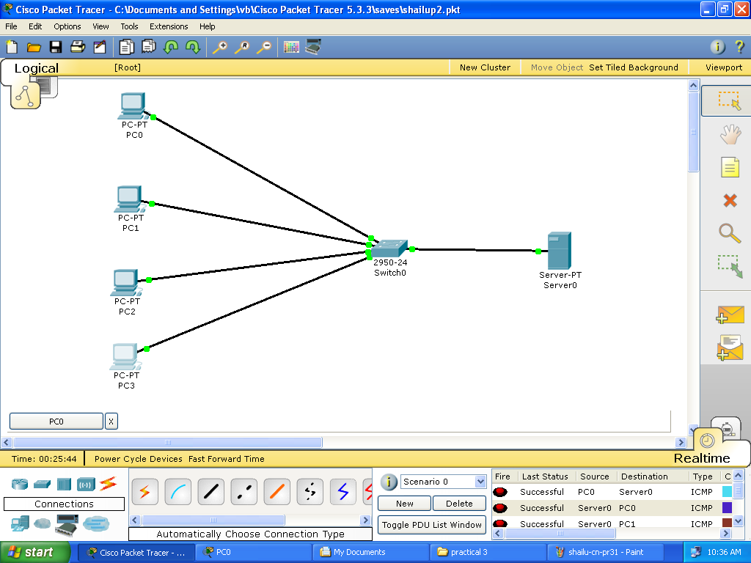

Step-3:Click on server -> Go to Config -> Click on DNS and add domain name and ip-address as shown in figure below.

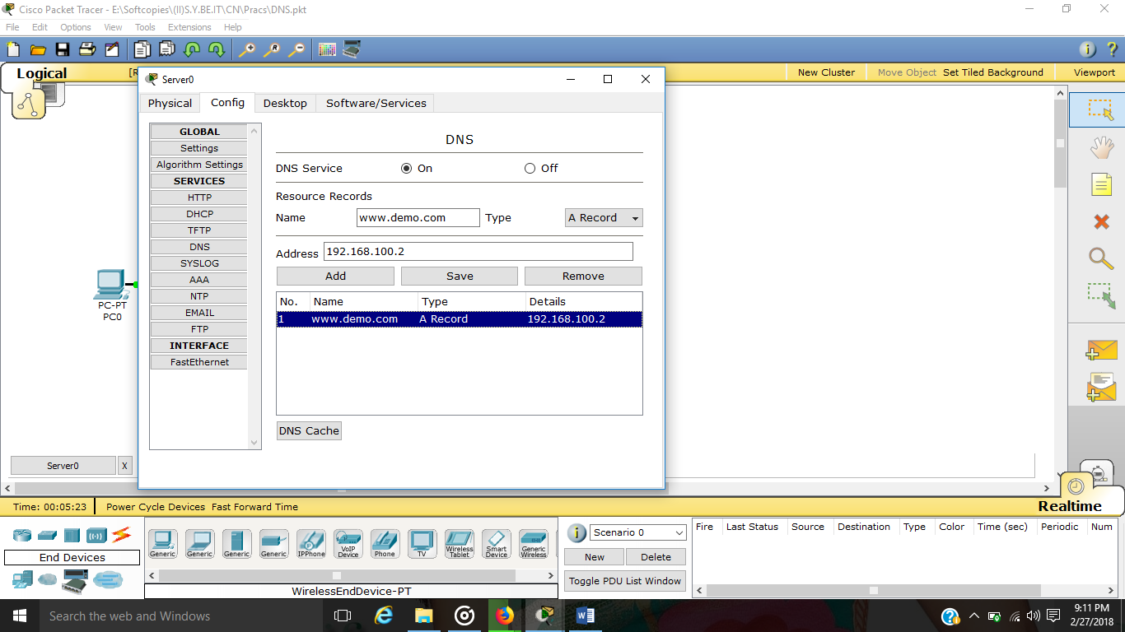

Step-4: Inconfig ->Click on HTTP and make html pages as shown below.

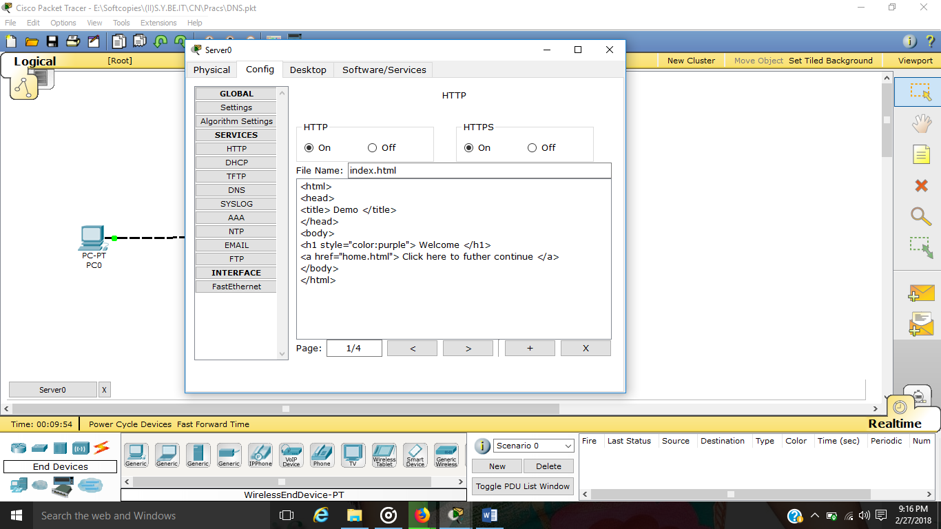

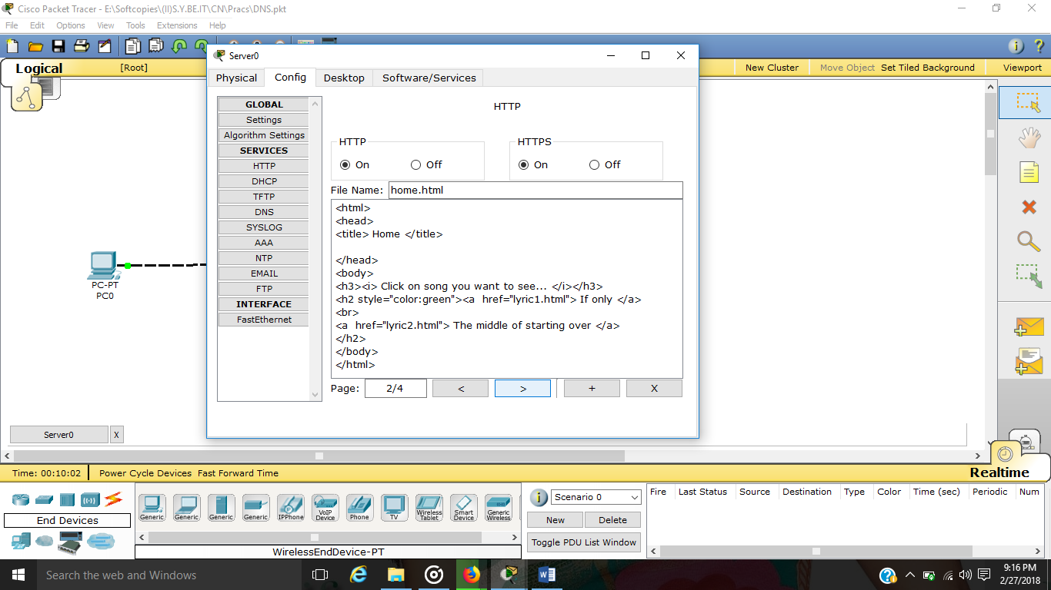

Step-5: Click on end device (PC or Laptop) -> Go to Desktop -> Go to IP Configuration and give IP address and subnet mask etc…

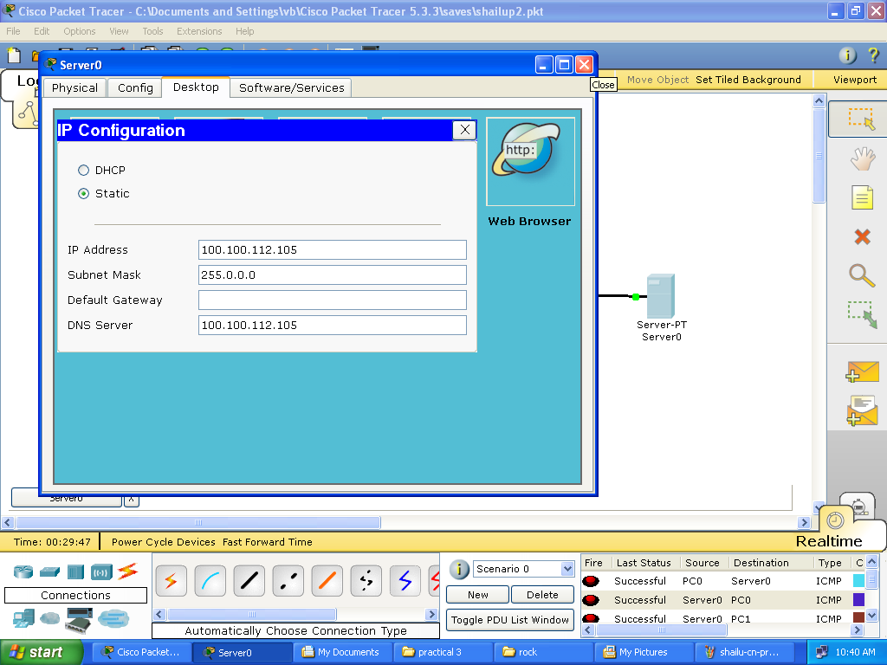

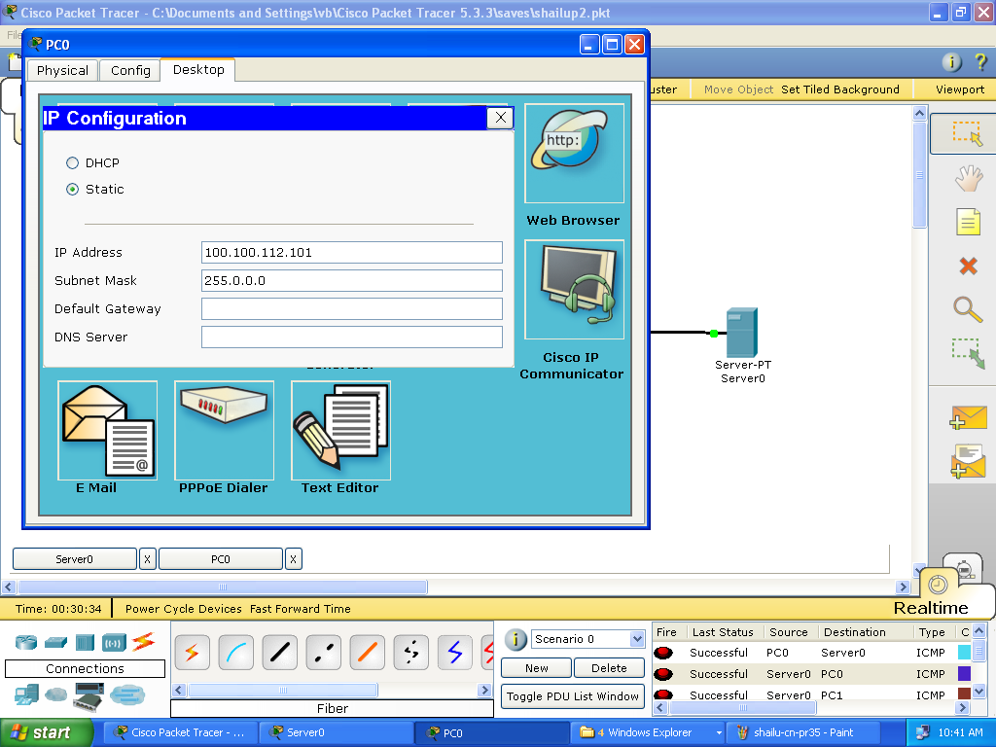

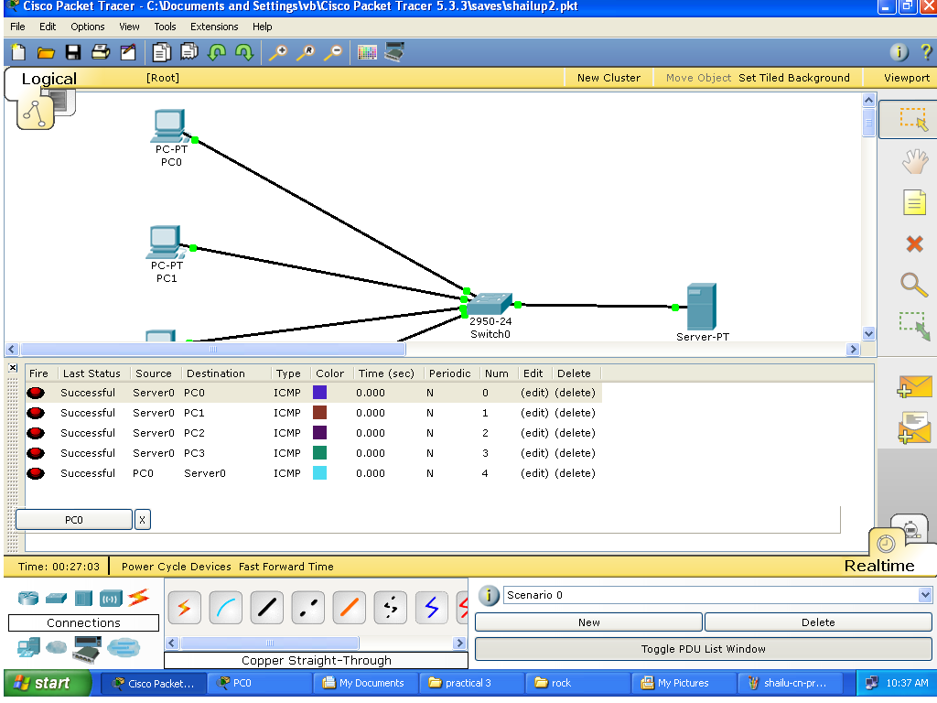

Step-6: In Desktop -> Click on Web Browser and now enter domain given in server in address bar of web-browser as shown below.

